Answers

# Activity 1



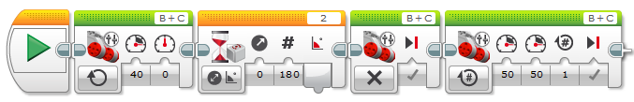



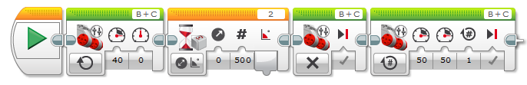



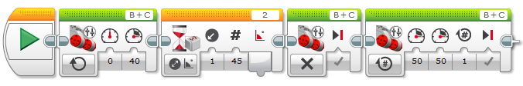

# Activity 2

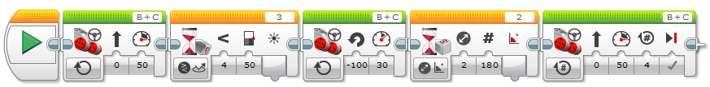

# Activity 3

